# Heroku: <https://blogserver1.herokuapp.com/>

# GitHub[: https://github.com/Utshab12/mernblogapp](:%20%20https:/github.com/Utshab12/mernblogapp)

# Introduction:

This is a blogging application by which any one can post their blog and share their thought with the other bloggers. You can also ask for the feedback about the blog, to others bloggers. Blogger can give feedback on any blogger’s blog by using comment box.

This application can be used for the Q/A website where everyone can share their problems on the website and other can give possible solutions of the particular problem and can share their thoughts about any article.

# User Stories:

1. The only user is blogger who utilize the following services;

|  |  |
| --- | --- |
| **User Type** | **Story** |
| Blogger | Blogger can sign up to the account by filling the signup form. |
| Blogger | Blogger can login to their account by filling the login form. |
| Blogger | Blogger can publish their blog by using the create your blog form. |
| Blogger | Blogger can also able to edit their blog by click on the edit button. |
| Blogger | Blogger can also able to delete their blog by click on the delete button. |
| Blogger | Blogger can view their published blogs in their profile page. |
| Blogger | Blogger can view all the blogs which are from other bloggers. |
| Blogger | Blogger can comment on other users blog. |
| Blogger | Blogger can delete the own created comments by click on the delete button. |
| Blogger | Blogger can also able to view all the comments on their own created blogs. |

# Website Sketch:

## Sign up Page:

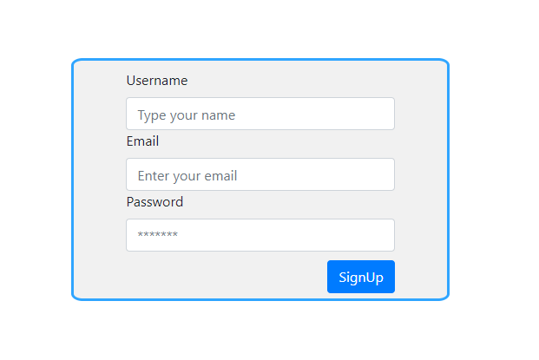

## Log in Page

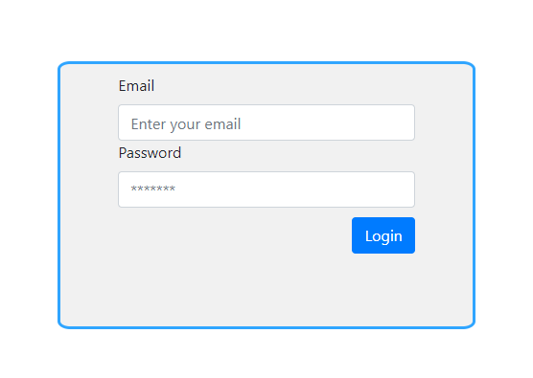

## Community Blogs

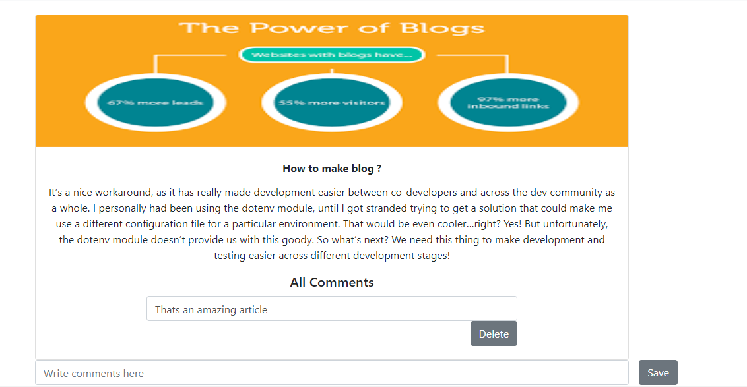

## Navbar



## Publish New Blog



## Create New Blog

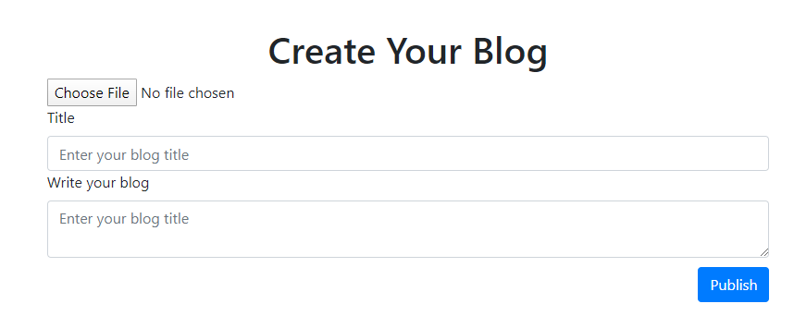

## Edit Blog

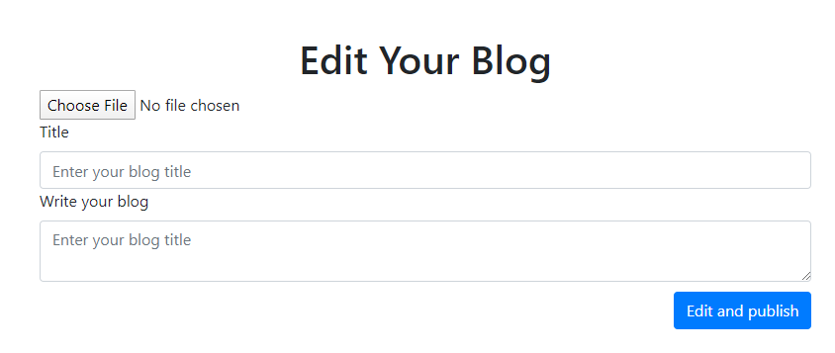

## My Blogs

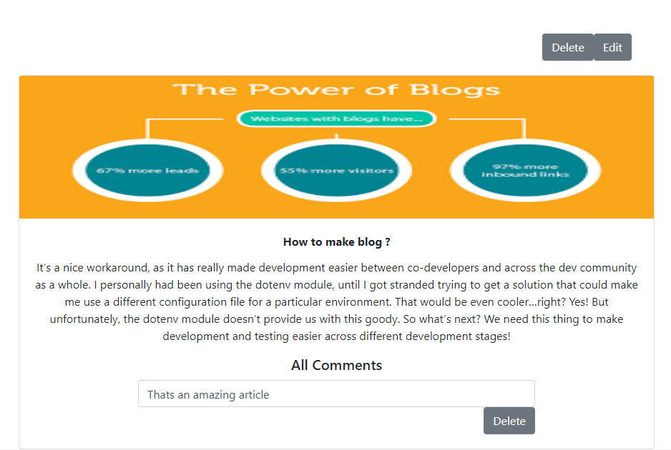

# List of APIs

## Signup:

https://blogserver1.herokuapp.com/user

## Login:

https://blogserver1.herokuapp.com/user/login

## Logout:

https://blogserver1.herokuapp.com/user/logout

## Create new Blog:

https://blogserver1.herokuapp.com/user/blog

## Edit blog:

https://blogserver1.herokuapp.com/user/blog/edit/:id

## Delete blog:

https://blogserver1.herokuapp.com/user/blog/del/:id

## Community Blogs (All Blogs):

https://blogserver1.herokuapp.com/blogs

## Create Comment:

https://blogserver1.herokuapp.com/blog/comment/:id

## Delete Comment:

https://blogserver1.herokuapp.com/blog/comment/del/:id

# Description

# Front-End

# Sign Up Page:

This page is used to create account if user want to register on the website. He just has to fill up the sign up form with the name, email and password. And just click on the sign up button to create account and register itself on the web application.

### Login Page:

This page is used to login into the website. User can able to login into the website after signup. You just have to provide the credential such as email and password in to the login form and click the login button. If your credential is true then the system will redirect to the community blogs page otherwise, system show the error message.

### Community Blogs page:

The system shows you all the published blogs on this page and user can also able to comment on any blog. And can able to delete the comment which is created by the logged in user.

### My Blogs page:

The system shows you all the published blogs on this page which are created by you. You can also edit and delete any blog by clicking on the respective button. You can also able to view all the comments given by other bloggers.

## Backend

The backend is developed in the node js and Mongodb for making the API endpoints. We are using mongo atlas which is online data storage to stores the data.

We developed the server in express js and we deployed it to the heroku and then use these endpoints in the client side to interact with the mongo atlas. All the endpoints which are using in this application are provided above.

## Working of application

When you run the application by running the following commands such as:

1. cd client
2. npm start

If you are logged in already into the browser, then system will redirect you to the community blog page and if you are using this application first time it will show you the sign up, if you already have account than just click on the login button and login into the app by providing the following credentials such as your email and password.

When you logged in, system will redirect you the community blogs.

You can click on my blog button if you are logged in then it will redirect you to my blog page where only create blog form will render. And you can publish your blog from here. And if you want to see your published blog again click on my blog button to rendered all the publish blogs by you. You can edit and delete by clicking the respective button provided above the blog.

## What I learned?

1. I learned how to deploy the application on the heroku.
2. I learned how to connect to server with the mongo atlas.
3. I learned how to use the jsonwebtoken npm js library .
4. I learned how to use reactstrap frontend react library .

## What I do different?

I want to make my app to quick login. Like facebook, if you logged in into the app and your session is created then if you close the browser session will present into the browser. And when you come again into the app, system will automatically redirect you to the blogs page instead of rendering login page. This is good try from my side.

## Stories

1. When I started to deploy the server I faced a lot of difficulties such as how to set the environment variables of the Mongodb connection. And how to set up the heroku for the node js etc but it resolved after some researched reading article from the medium and harckernoon etc.
2. When is try to upload it to the github then there was a little problem to set the remote origin because it push the code to the previous added origin but it also resolved after spending time on reading articles about this issue form github and medium etc.